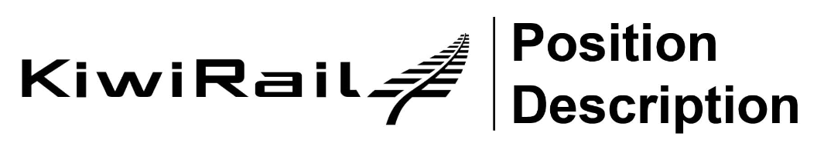

TRAINEE SIGNALS EQUIPMENT TECHNICIAN
Network Services

Purpose:

To provide effective, reliable and efficient overhaul of signalling relays and other associated signalling equipment and components when necessary under the supervision of the Leading Hand Signals Equipment Technician.

Ensure work is carried out in a way that complies with all KIWIRAIL quality, safety and engineering standards. Health and Safety is an important part of how KiwiRail operates. You will be a safety leader and will be expected to “walk the safety talk”.

Dimensions:

Reports to: STE Manager
Responsible for: Nil
Location: Local Depot - Some travelling/overnight may be required
Budget: Nil
Internal Contacts: Signals Equipment Technicians
Signals Field Engineers
Signals Maintainers/ Technicians
Technical Services STE team
Planners
Regional Managers
Other area staff
External Contacts: Members of the Public
Contractors
External Customers

Key Accountabilities

Signals Activities
- Under full supervision operate and maintain a range of testing instruments,
- Under full supervision use and understand electrical measuring instruments
- Complete forms and documents as and when required
- Contribute to team decisions and Tool Box Meetings
- Maintain a customer service focus and display professional behaviour when dealing with, associated client personnel, sub contractors and members of the public.
- Such other duties and responsibilities as the Company may require from time to time
- Ensure you clearly document your work activities and established files are clearly identified and filed correctly
- Such other duties and responsibilities as the Company may require from time to time
Zero Harm
- Responsible for complying with all rail safety system standards, procedures and statutory requirements within your area of responsibility
- Responsible for your own safety and that of other rail employees, contractors and visitors within your work environment
- Responsible for the identification, reporting and initial control of any safety or environmental hazard identified within your area to your immediate manager
- Adhere to Kiwirail’s health and safety requirements and take responsible for maintaining a proactive approach regarding both personal wellbeing as well as that of fellow employees, associated client personnel, sub-contractors and members of the public.
- Report all accidents and incidents to your immediate supervisor within one hour.
Training and Development
- Undertake both On The Job Training for the set designation plus attend training courses run by the company, or external agencies as and when required to fulfil the requirements of the position
- Acquire On The Job Training competencies for the set position and the modules are successfully completed

Person Profile

Essential: | Desirable:
- Experience of working as part of a team  - Successfully complete Induction training.  - Successfully complete all On The Job training tasks for a Trainee Signals Equipment Technician  - Relevant experience of working in labouring or manual work | - Past experience of assembling electrical equipment

Education:

Essential: | Desirable:
- NCEA Level 1 in Maths, English and Science or equivalent  - Restricted Class 1 New Zealand drivers licence | - Full class 1 New Zealand drivers licence  - EST Level A/B

